Osprey Design Experience Weekly Memo

**TEAM NAME**: Green Ellipsis – Upcycling of Single Use Plastic Softdrink Bottles

**DATE**: 09/16/2022

**ATTACHMENTS:**

1. Report Introduction

**MEMO AUTHOR:** Antonio Mendoza

**WORK COMPLETED THIS WEEK**:

* Wrote Report Introduction due 9/16/2022

**WORK TO BE COMPLETED NEXT WEEK**:

* Preliminary Budget due 9/23/2022
* Preliminary Work Breakdown 9/23/2022

**TEAM HOURS**:

|  |  |
| --- | --- |
| Name | Hours |
| Antonio Mendoza | 7 |
| Christian Ventouras | 9 |
| Nicholas Wedyck | 7 |
| Tyler Johns | 9.75 |
| Marc Caina | 9 |
| Total | 41.75 |

**1)**

**Background Information [Nick/Tony]**

Green Ellipsis is a local engineering service that was established in 2015. The current mission statement, “Green Ellipsis dreams of and designs for a sustainable humanity,” is the driving force of the company. Since the beginning, Green Ellipsis’ goal has been to bring sustainable engineering to the local community and beyond whilst also mitigating waste. In addition, Green Ellipsis prides itself on influencing others to move away from the current reliance on plastics. This is done by using the well-known mantra of reduce, reuse, and recycle whenever possible. Moreover, The United States Environmental Protection Agency (EPA) cites the notion of reduce, reuse, and recycle as a way that individuals and groups can assist the community and environment in saving energy and natural resources [1]. This closely aligns with the goal Green Ellipsis is trying to accomplish about designing for a sustainable humanity.

Most of Green Ellipsis’ work is centered around 3D printing. During the height of the Covid pandemic, Green Ellipsis helped with the design, manufacturing, and distribution of over 10,000 face shields to hospitals in North Florida and health care providers in Indiana and New York. Green Ellipsis has also designed parts ranging from a shower curtain hook to a power supply cover that could be 3D printed by anyone. Recently, Green Ellipsis has become a part of the open-source pultrusion community. This shifted the design focus of Green Ellipsis toward the recycling of polyethylene terephthalate (PET) plastic bottles, specifically for hobbyists. These PET bottles are recycled by converting the usable portions into 3D printer filament. Once the plastic is recycled, it can then be reused to create useful 3D printed objects. The current device for converting PET plastic bottles into 3D filament is shown in Figure 1. One day, Green Ellipsis hopes to publish the solutions found for the PET recycling process to the community as a kit for any hobbyist to recreate. Figure 2 shows an example of what a potential kit could look like. This kit would include assembly instructions, parts, and hardware to properly assemble the device.

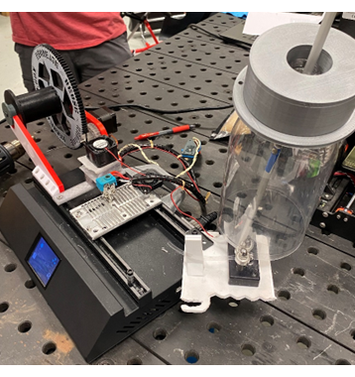

*Figure 1: Current Apparatus for Converting PET Bottles into 3D Printer Filament*

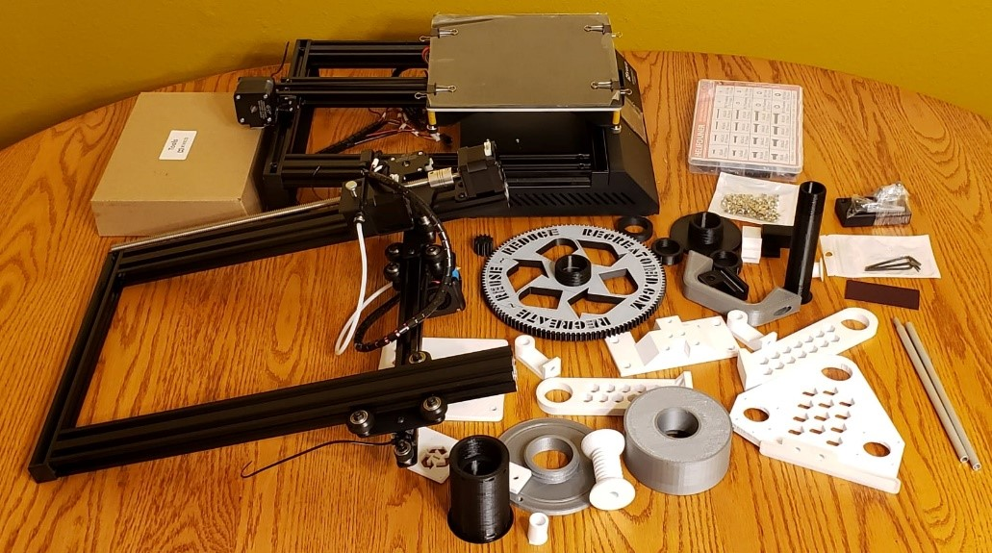

*Figure 2: Disassembled Kit of the Current Apparatus for Converting PET Bottles into 3D Printer Filament [2]*

**Problem Statement [Christian]**

Single-use polyethylene terephthalate bottles continue to pack landfills around the country. Because of this, the need for recycling and upcycling of PET grows greater every day. 3D printers can uniquely contribute by upcycling PET bottles into PET filament. Green Ellipsis has a solution to this issue that converts plastic bottles into 3D printer filament. Figure 4 shows the current device used by Green Ellipsis, which is mostly a manual process. This method of upcycling PET bottles cuts a two-liter bottle into one long strip. The strip is then pulled through a heated chamber which deforms the plastic into usable filament. Currently, this process is intensely laborious. Therefore, it would not be suitable for hobbyist use, which is the current end goal for the device. To solve this problem automation is required. There are seven main components to the solution (Figure 3):

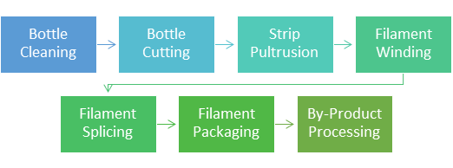

*Figure 3: Process Overview for PET Upcycling*

Automating these components would reduce the labor required by the user to produce PET filament. Additionally, it would provide an easy option for hobbyists to recycle single-use PET bottles into reclaimed filament. The design must automate at least one of the components, while generating no additional waste. Bottle Cutting was chosen as the optimum process to automate. The method used to make this decision is described in the Design Alternatives and Decision Making Process section.

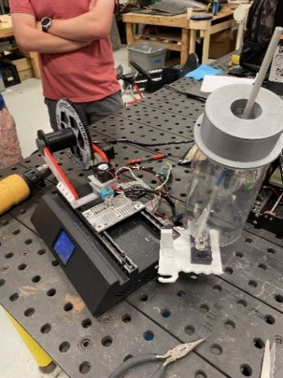  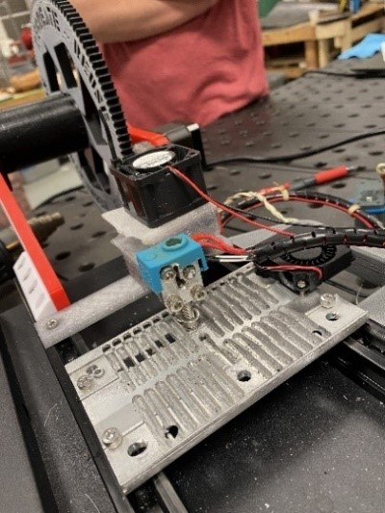  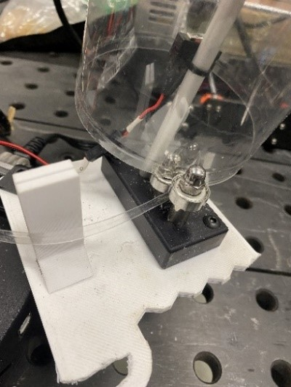

*(a)                                                          (b)                                                            (c)*

*Figure 4: (a) The Overall System (b) The Hot End and Pultrusion Device (c) The PET Bottle Cutter*

The following are the design requirements and constraints for this project. They are broken down into four sections: Global Requirements, Global Constraints, Process Specific Requirements, and Process Specific Constraints. The global requirements and constraints establish the conditions for the overall process. The process specific requirements and constraints list the conditions that affect the individual step that is automated. Each requirement and constraint was established based on the project description, as well as meetings with Green Ellipsis.

**Global Design Requirements** `

* Automation of at least one step in the process
* Reduce duration of reclamation process
* Minimize PET bottle waste
* Minimize the number of tools needed to complete the process
* Process must accept unwashed two-liter bottles

**Process Specific Design Requirements**

* Must cut off the bottom of the bottle without imperfections
* Must begin the pultrusion strip by cutting a 1.75mm wide ribbon from the bottle
* Must prioritize health and safety of the user

**Global Design Constraints**

* Machine needs to fit in a 75cm by 240cm area
* Must run off standard wall power (120Vac/60hz)
* Must not produce excess hazardous fumes
* Must use environmentally friendly chemicals (i.e. not petroleum based)

**Process Specific Design Constraints**

* User must not be able to cut themselves easily
* Approximately $1,000 budget
* Additional money is available if justified

**Theoretical Concepts [Tyler/Marc]**

**What is Additive Manufacturing?**

Additive Manufacturing, also known today as 3D printing, is the opposite of traditional manufacturing. Getting its start in the 1980s, additive manufacturing utilized computer aided design to generate objects by building them up layer by layer. Not until the early 2000s did technology allow a level of precision comparable to that of traditional manufacturing. After the expiration of patents in 2009, many affordable 3D printers popped up all around the world and led to a new community-driven interest in 3D printing [3].

3D printers are widely used today, and the most common one is fused filament fabrication (FFF), also known as fused deposition modeling (FDM).

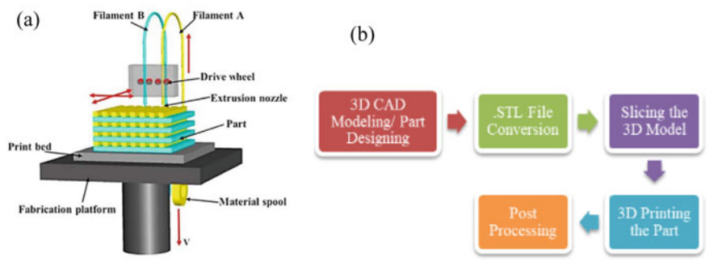

*Figure 5: (a) FFF Process (b) Process of 3D Printing*

Figure 5a shows the FFF process. First, the material feed is a spool with a diameter of 1.75mm or 3mm. It is then extruded via a drive wheel through a heated chamber more commonly known as the hot end. This brings the material to melting temperature where it is deposited onto the print bed layer by layer [3]. There are many types of material that FFF can use. The most common being polylactic acid (PLA), however, there are ASA, ABS, HIPS, nGen, PETT and PETG (both cousins of PET).

Figure 5b shows the entire 3D printing process. First, the object is created in a Computer Aided Design (CAD) software. After it is exported into a stereolithography file, it is imported into a software known as slicing software. This converts a three-dimensional object into tool paths that the printer can understand. It also configures and includes other necessary items not in the CAD file required for printing such as supports, infill density, and color changes. Afterwards, the part is printed, and the printer has certain conditions set by the slicer such as fan speed, tool speed auto leveling, and minimum layer time. With other types of 3D printing, there is much more post processing required, but mostly for FFF it usually only consists of removal of support material [4].

In addition to the software needed to print, it is also necessary to know which firmware the 3D printers run on. One of the most widely used open-source firmware is the Marlin firmware, derived from GRBL and Sprinter. Both of which are firmware utilized in machine control and CNC machining [5]. Marlin firmware is mainly used in rapid prototyping. It can accommodate Delta, Cartesian, SCARA, and Core XY printing formats using G-code [5].

**The Making of Polyethylene Terephthalate (PET)**

Polyethylene terephthalate, also known as polyester, is made through an esterification process of combining the monomers, ethylene glycol and terephthalic acid. Under elevated temperatures and low vacuum pressure, water and polymer chains are created. During this step, the PET is in a viscous liquid stage, which is then extruded forming a glass-like amorphous matter. A second polymerization stage removes impurities that provide the PET its toughness, stiffness, and resistance to creep, as well as its flexibility [6]. A visual of this process is shown in Figure 6. This stable polymer is highly resistant to chemical and biological reactions to other materials, making it a viable option for packaging foods, beverages, and many other consumer products [7]. After the melted polymer has been made, it is either spun or drawn into fibers or solidified. Subsequently, PET films are made through extrusion; molten PET can be blow-molded into desired shapes and PET pellets can be cut from the solidified polymer [8].

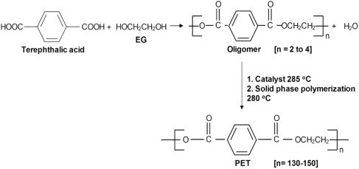

*Figure 6: The Chemical Process of Producing Polyethylene Terephthalate [6]*

**Plastic Waste**

Polyethylene terephthalate is one of the most widely available semicrystalline thermoplastics. It is used in many industries for its tear and tensile strength, food-safe uses, and gas barrier properties. Invented in the 1940s by J.T. Dickson, it was not commercially used until the 1960s [9]. Because of this, PET plastics have become ubiquitous with food and liquid packaging. Most PET bottles are intended for one-time use and are generally thrown out afterwards. Despite PET bottles being easily recyclable, it still has a low recycling rate        (Table 1).

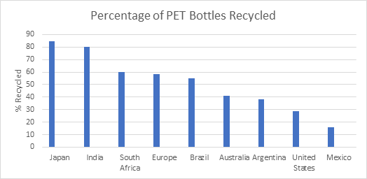

**PET Upcycling**

With the abundance of single-use PET bottles growing exponentially every day, upcycling has been a solution to help minimize this waste. Upcycling is the process of repurposing single-use items, such as plastic bottles, to create a product of higher quality or value [10]. The benefit of upcycling compared to recycling is that upcycling requires less energy input and removes the need for virgin materials to create a new product [10].

There are many ways to upcycle PET bottles. One of the main ways is to repurpose the bottles for everyday use, such as planters or containers. However, recent advancements in technology have made upcycling of these bottles more prominent for the use of 3D filaments. Since a majority of 3D printing requires a plastic material feed, the upcycling of PET bottles is an innovative solution to the pollutant waste [11].

**PET Upcycling Process**

A community has emerged to promote the upcycling of PET bottles that were not recycled. The seven main processes can be seen in Figure 7. The first iteration was by Joshua Taylor of Recreator 3D [12] as seen in Figure 8.

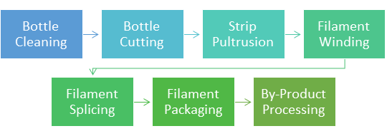

*Figure 8: Process Overview for PET Upcycling.*

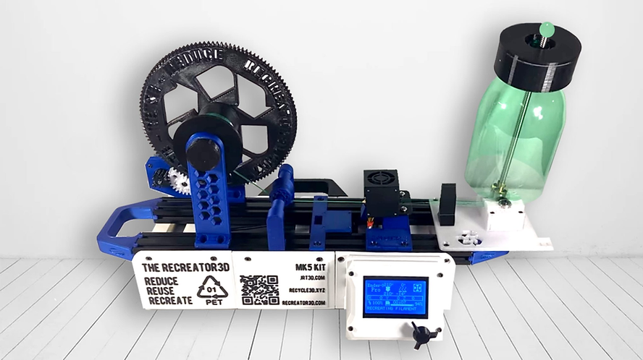

*Figure 9: Joshua Taylor's Recreator 3D.[12]*

In this configuration, the bottle is prepared before being turned into filament. The bottle cleaning process is the first of seven steps to upcycling PET bottles. First, it is cleaned of debris with the heat-bonded adhesive and the label still attached. A quick rinse for the inside of the bottle removes enough debris for the process. Afterwards, the bottle’s label is removed, and the label’s adhesive is removed with a degreaser and abrasive scrub pad. The second step is the bottle cutting process, where the bottom of the bottle is cut off. Next, a thin strip is started and cut approximately 5.5mm in length. However, this depends on the thickness of the container given, as shown in Figure 9 [12].

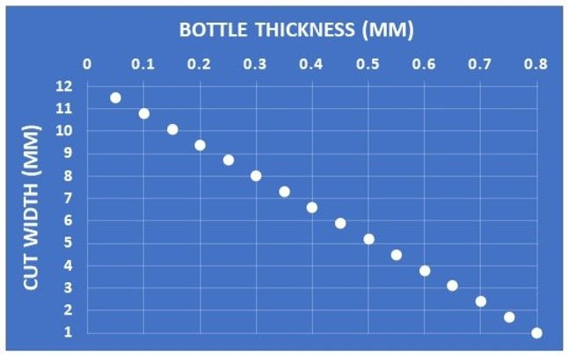

*Figure 10: Bottle Thickness VS Strip Width for 1.75mm Filament Creation [12]*

A narrow strip must first be created to start the strip pultrusion. This strip starts out as a fine point and gradually widens to the appropriate width based on the bottle thickness. In the Strip Pultrusion step, the previously cut strip is pulled through the hot end and wound around the moving spool. To ensure proper operation of the pultrusion process the hot end must reach a proper temperature of 234℃. Due to the hot end temperature being below the melting temperature, a circular or “U” shape is formed with a void in the center of the filament from the pultrusion process [12].

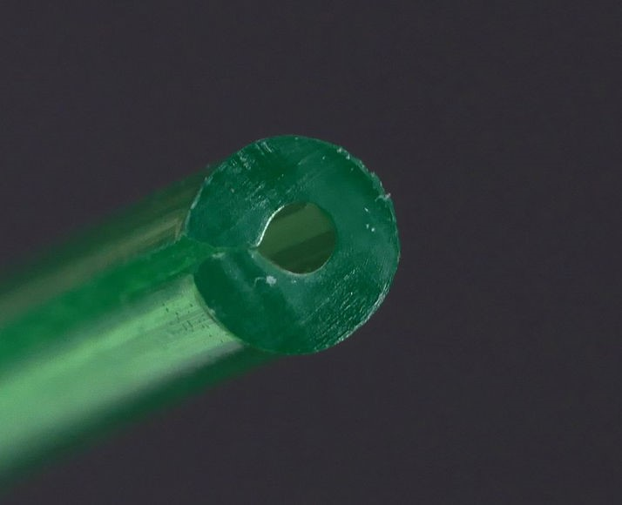

*Figure 11: Reclaimed PET After Being Formed into 1.75mm Filament [12]*

After winding the molded filament onto the spool, the stepper motor driving the spool continues to pull the newly formed filament. This completes the pultrusion process until the PET bottle runs out of usable material. When performing this process, around 25 grams of filament can be made from a single bottle. Filament splicing would be the next process to occur after the bottle gets used up. However, splicing PET is tricky due to the crystallization of PETP from prolonged heat exposure without proper cooling [12]. In the Filament Packaging step, the filament must be dried before it can be used for 3D printing. This can range from commercial equipment to an oven set to 150℃. After being dried it must be stored in airtight packaging with desiccant to avoid moisture absorption. The last process is By-Product Processing. In this process, the top and bottom of the bottle can be recycled or upcycled. Currently, this has no definitive process, however, multiple options are available. The leftover bottle can be pressed into pucks or ground up into shredded PET for injection molding.

**References**

[1] US EPA. *Reduce, Reuse, Recycle*. Available: https://www.epa.gov/recycle.

[2] (). *Green Ellipsis*. Available: https://m.facebook.com/GreenEllipsis/.

[3] J. M. Jordan, *3D Printing.* 2019. DOI: 10.7551/mitpress/11800.001.0001.

[4] Krishnanand and M. Taufik, "Fused filament fabrication (FFF) based 3D printer and its design: A review," in Anonymous 2021, . DOI: 10.1007/978-981-15-9853-1_41.

[5] Anonymous (-08-29T19:01:27-05:00). *What is Marlin?*. Available: https://marlinfw.org/docs/basics/introduction.html.

[6] A. M. Al-Sabagh *et al*, "Greener routes for recycling of polyethylene terephthalate," *Egyptian Journal of Petroleum,* vol. 25, *(1),* pp. 53-64, 2016. Available: https://www.sciencedirect.com/science/article/pii/S1110062115000148. DOI: https://doi.org/10.1016/j.ejpe.2015.03.001.

[7] (). *About PET*. Available: http://www.petresin.org/aboutpet.asp.

[8] William Hosch, "polyethylene terephthalate," 2009. Available: https://www.britannica.com/science/polyethylene-terephthalate/additional-info#history.

[9] S. Thomas, *Recycling of Polyethylene Terephthalate Bottles.* 2019.

[10] K. Sung, "A review on upcycling: Current body of   
literature, knowledge gaps and a way forward," in Anonymous Venice, Italy: 2015, pp. 28-40.

[11] Exconde, Mark Keanu James E. *et al*, "Materials Selection of 3D Printing Filament and Utilization of Recycled Polyethylene Terephthalate (PET) in a Redesigned Breadboard," *Procedia CIRP,* vol. 84, pp. 28-32, 2019. Available: https://www.sciencedirect.com/science/article/pii/S2212827119309916. DOI: https://doi.org/10.1016/j.procir.2019.04.337.

[12] J. Taylor. (august). *MISSION - Recreator 3D*. Available: https://joshuartaylor.wixsite.com/recreator3d/mission.